**Working with Databases In Elastic Beanstalk**

* Create a Database in RDS
* Python Django:
  + Create the Python django application deployment as shown in the class
  + Now navigate to elastic beanstalk and choose Environments and select the environment created 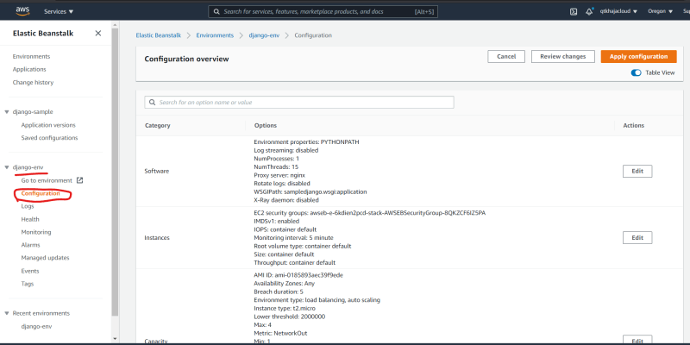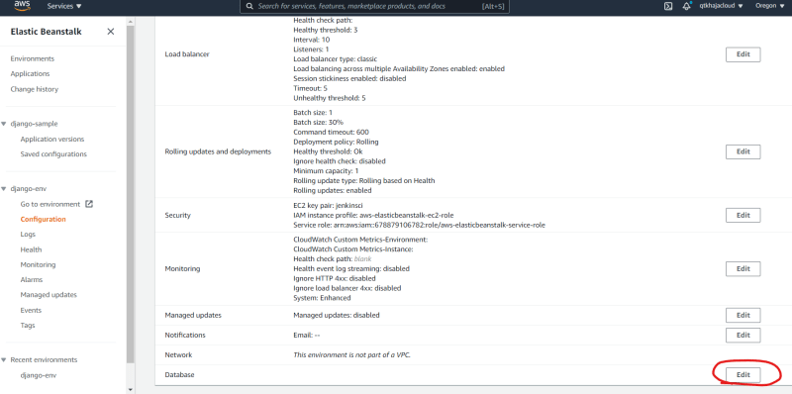

Configuring RDS settings overthere create the following properties

* + - RDS_HOSTNAME
    - RDS_PORT
    - RDS_DB_NAME
    - RDS_USERNAME
    - RDS_PASSWORD

Now to configure the Database from code read the above properties from environmental variable 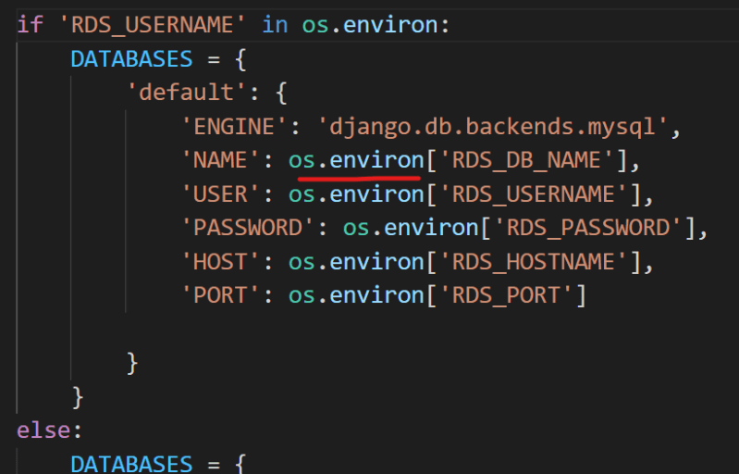

**Serverless Computing**

* Serverless is not actually serverless, it means users only need to manage code/application and not servers.
* Servers will be managed by Service Provider.
* We as users only pay when our code or function is executed in the server managed by provider
* AWS Lambda, Azure Functions and gcp cloud functions are examples of serverless computing or Functions as a service (FaaS)
* Benifits:
  + Faster time to market
  + No need to worry about infra provisioning
  + Creating functions in multiple languages that are supported by cloud provider
* Drawbacks:
  + Not portable: There is no standard implementation of Functions as a Service. If you have written serverless in AWS and now want to run the same implementation in Azure, we need to rewrite the code